**WIREFRAME – Street Fighter With JQuery**

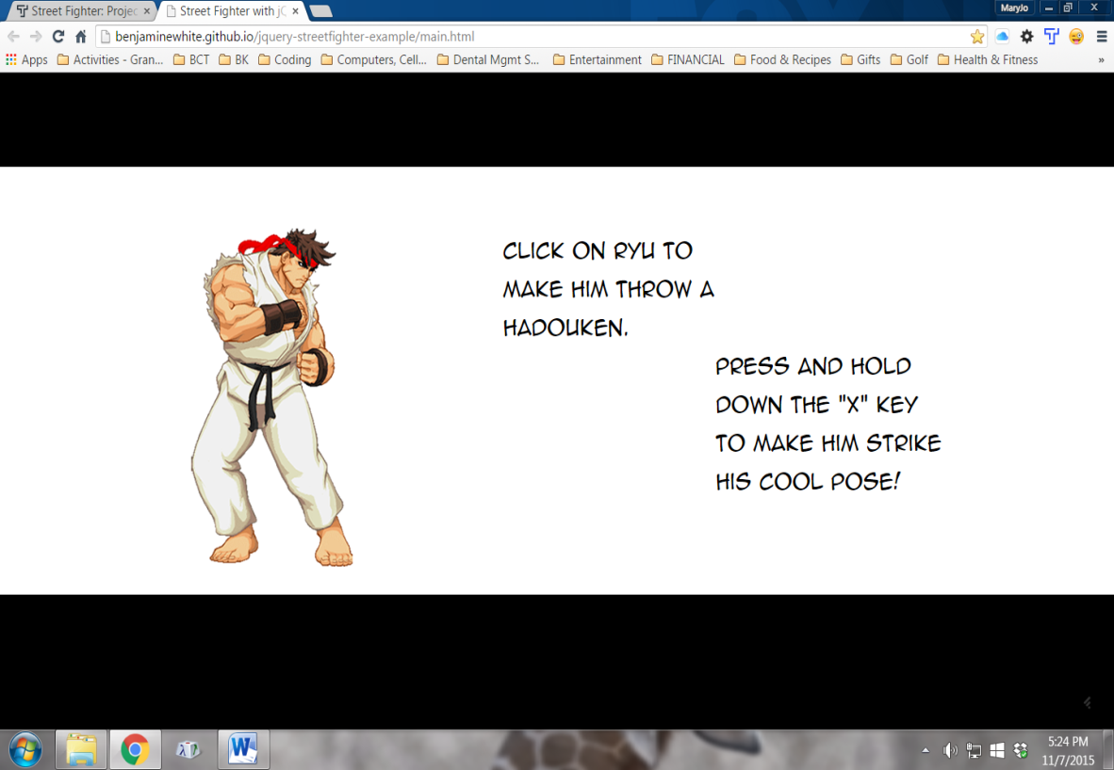

**Landing Page**

1. Main screen shot above --^
2. After HTML loads and is ready … call main JS scripts! Keeps design clean and ensures all element tags are available to reference with JQuery!

$(document).ready(function() {

intro();

playGame();

});

function intro() {

…..

}

function playGame() {

…

}

**IMPLEMENTATION**

1. Fork the Github repo … <https://github.com/Thinkful/streetfighter-starter>
2. Create algorithm / logic flow
3. Generate HTML & CSS
   1. Black background
   2. Center container w/white background
      1. Container has 2 inner containers.
      2. Fighter image container floats left with left-side padding, vertically centered within container. Images change upon mouse events.
      3. Text container is mostly centered, but 'how-to' instructions at end of slide show will be offset from one another for easy reading. Text will fade in/out of this container upon startup, then stop on 'how-to' instructions.
   3. Upon page load, fighter is in 'still' pose.
4. Event handling. Upon mouse events, fighter image changes. USE ANIMATE() function, and 'chain' together handler functions!
   1. Upon load
      1. Play music and intro text that fades in/out next to fighter image.
      2. Event watchers wait ….
   2. Upon each event, do the following:
      1. .mouseenter() … Mouse moves over fighter image container
         1. .hide() current pose
         2. .show() 'ready' pose
      2. .mouseleave() … Mouse leaves fighter image container
         1. .hide() current pose
         2. .show() 'still' pose
      3. Mouse ***clicks*** on fighter
         1. .mousedown() … mouse key goes DOWN
            1. Change image to be " ryu-throwing-hadouken"
            2. Play 'hadouken' sound clip
            3. Start the hadouken gif displaying across the screen w/ 'animate()
         2. .mouseup() … mouse key comes UP.
            1. Fighter returns to 'still' pose.
      4. Watch for .keydown() ……. Use ".keyCode" property of ".keydown()" method.
         1. If .keydown() ***value = "***x" or "X"
            1. Fighter changes to 'cool' pose.
         2. Upon .keyup()
            1. Fighter returns to 'still' pose.